Dissertation dev log
Week 2:
Current Goals for prototype session:
- A working way of profiling the results of the prototype
- Comprehensive background done, covering triangulation, fracturing methods used in games, Graphics API’s, Performance of Graphics API’s, Point sampling, and Voronoi Clipping.
- An introduction that provides clear context for the project, and explains the need for the research, including positive impacts and who benefits. It should also highlight the motivation for the project.
- A Critical Review of current technology is completed, that highlights where the gap in research is, and the how this project fills it.
- Clearly stated research question
- Clear, feasible hypothesis, that is well scoped.
- Readme that highlights development roadmap
- A methodology for how the project is going to be researched, and how its going to be evaluated
- Professional, ethical, sustainable, legal, and social review carried out.
- Project is ethically robust
- A plan for security and privacy concerns has been written, and data is well managed.
- Profiling results that are easily replicated and are well documented.
- Project plan with gantt chard
Current Strech goals for prototype:
- Working Voronoi fracture in 3D
- Fracture implemented in both OpenGL and Vulkan
- Voronoi clipping implemented
- A way to interact with the fragmented mesh
- An implementation in GLSL, for performance comparison
Completed:
- A working Voronoi fracture in 2D for demonstration

Development notes:
I have successfully completed the 2D Voronoi fracture. This was my challenge from week 1, and I resolved it by reading about Voronoi from spatial tessellations: concepts and applications [2], and watching a YouTube explanation, a simple algorithm for 2D Voronoi diagrams [1]. This helped me understand how Voronoi diagrams work and allowed me to implement a simple half plane intersection method for creating a Voronoi diagram. This also helped to resolve another challenge, how to implement a 3D version, as this gave me the insight into the subject to come up with a plane for a 3D implementation. The pseudocode for that can be seen in Fig 1.
Next im going to be working on my literature review, and a 2D Voronoi fracture in Vulkan.
Resources:
Figure 1:
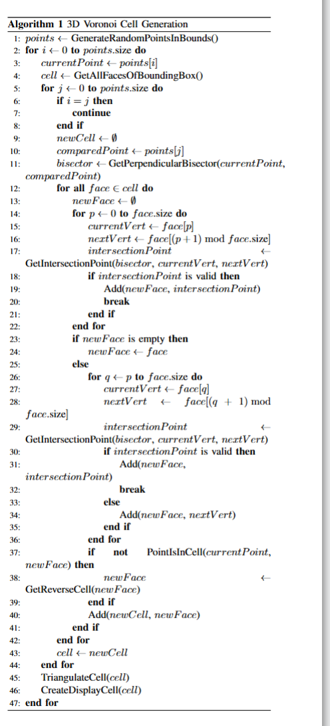

References:
[1]
Edgar Programmator, A simple algorithm for 2D Voronoi diagrams, (Sept. 21, 2023). Accessed: Oct. 25, 2025. [Online Video]. Available: https://www.youtube.com/watch?v=I6Fen2Ac-1U
[2]
A. Okabe, B. Boots, K. Sugihara, S. N. Chiu, and D. G. Kendall, ‘Spatial Tessellations: Concepts and Applications of Voronoi Diagrams, Second Edition’.

